Child and Parent Interview: Age 7-11

Daphne O. Pack
Department of Home and Family, Brigham Young University—Idaho
CHILD 310: Early & Middle Child Development
Brother Trevor Rowe
December 8, 2025

Introduction
I had the opportunity to interview my eight-year-old cousin Arthur. He and his family live in Utah so I had a video call with him and his mom. They were at their house about to eat dinner, which was perfect because I decided to focus on the daily routine of eating and mealtime.

Interview Questions
Listed below are the questions I used in this interview.
- What’s your favorite mealtime and why? (Child, understand and evaluate)
- What are your favorite foods? (Child, remember)
- What’s your plan/strategy for healthy eating? (Parent, understand)
- Do you like to try new foods? Like what? (Child, apply and analyze)
- Are there foods you like now but didn’t use to like? (Child, remember and evaluate)
- What ways do you help your parents get ready for dinner? (Child and parent, understand and apply)
- Has he ever shown interest in cooking? (Child and parent, remember)
- Does he have good table manners? (Parent, remember and understand)
- How is his attitude towards mealtime? (Parent, remember and understand)
- Is he ever in a hurry to finish eating? (Parent, remember)

Summary of the Interview
On this video call, I started with a brief introduction to the interview process and asked about their day. This segued nicely into mealtime because they were about to have dinner. I asked Arthur if he preferred breakfast, lunch, or dinner and he said dinner because sometimes they eat salmon. I asked if he liked salmon and he said it was one of his favorite foods! I asked what else he likes to eat and he said, “salmon, rice, lentils, and Hawaiian haystacks.” His mom Noelle added that he only likes certain foods and does not like vegetables or fruit. Arthur added that the only fruit he likes are apples.
With this information, I asked Noelle how she handles his distaste for vegetables and the desire to feed him a balanced diet. She laughed and said, “Oh I’ve given up on healthy eating.” She likes to try to disguise vegetables into meals so he can get more nutrients, but for the most part she lets him be picky. Then I asked if Arthur likes to try new foods and he said, “Not really.” With some more prodding, he explained that he already knows what he likes and doesn’t feel like trying anything else. I asked if he always liked his current favorite foods and both he and Noelle said yes. She couldn’t recall a time he’s tried something he didn’t like and ended up liking it later. But there are times when he says he doesn’t like something he’s had before and Noelle just needs to remind him that he likes it and he’s just fine.
Then I switched gears and asked what Arthur usually does when it’s time for dinner. He said, “I just go to the table and eat!” Typically, he doesn’t help set the table or cook, but he helps clean the dishes after dinner. I asked if he’s ever shown an interest in cooking and simultaneously Noelle said, “No” and Arthur said, “Yes!” Apparently, he’s never really participated in cooking a meal, but he shows interest in how foods are made when his mom cooks or bakes. He does occasionally make his own cereal or snacks in the microwave or toaster oven.
I asked about Arthur’s table manners and Noelle said he’s pretty good about it. I asked if he acts different in a different setting or with other people, and Noelle said he acts about the same, but Arthur said he acts better. His attitude toward mealtime is overall positive, especially dinner. Noelle will say it’s time for dinner and he’ll come running asking, “What’s for dinner?” He doesn’t complain about having to leave his previous activity, unless it’s video games, in which case he’s more begrudging. He’s a quick eater, and will hurry away from the table, especially when a food he doesn’t like is being served.

Reflection and Application
Through my interview with Arthur, I was able to make many connections with the typical development of eight-year-olds. For the most part, he acts exactly as described in the book, like “looks forward to meals” and “finishes meals quickly to resume previous activity.” (Marotz, 2023). He also “takes pride in using good table manners, especially when eating out or company is present; at home, manners are less of a concern.” (Marotz, 2023).
One thing that was different than expected was that Arthur does not like to try new foods. According to Marotz (2023), an eight-year-old “is willing to try new foods and some of those previously refused.” This did not align with Arthur’s claim to already know what he likes and not needing or wanting to try anything new. I learned that Arthur’s development of his daily eating routine is mostly on track with the typical eight-year-old, but he still has his individual differences like picky eating.
Based on the growth patterns described by Marotz (2023), Arthur fits perfectly within the description of “a more mature body shape and appearance; arms and legs grow longer creating an image that is tall and lanky.” Motor development wise, Arthur loves to run, play, and be active with his friends and older siblings. He also displayed a lot of energy, not being able to sit still on the video call and doing somersaults and making silly faces.
Noelle’s perspective added valuable insight to the interview by expanding on Arthur’s answers and prompting him when he lost interest in what I was saying. Her point of view also showed her efforts in child rearing and Arthur’s responses and behavior were evidence of that. The only surprise was that Arthur doesn’t like to try new foods, which contradicted the book.

Research Based Recommendation
Based on what I learned, I would recommend to Noelle that she try providing more nutritious food options for Arthur that are closely related to foods he’s already familiar with and likes. In an article by Cooke (2007), it says that “children’s experiences with food influences both preferences and intake, and research suggest that the earlier and broader that experience, the healthier the child’s diet.” Even though Arthur is eight, it’s not too late for him to broaden his diet. Arthur could slowly accept more nutritious foods if Noelle repeatedly offered them in new ways, like preparing vegetables differently with different seasonings or sauces.

References
Marotz, L. R. (2023). Developmental profiles: Pre-birth through adolescence. 9, 190-193.
Cooke, L. (2007). The importance of exposure for healthy eating in childhood: a review. Journal of Human Nutrition and Dietetics. 20 (4), 1. https://doi.org/10.1111/j.1365-277X.2007.00804.x

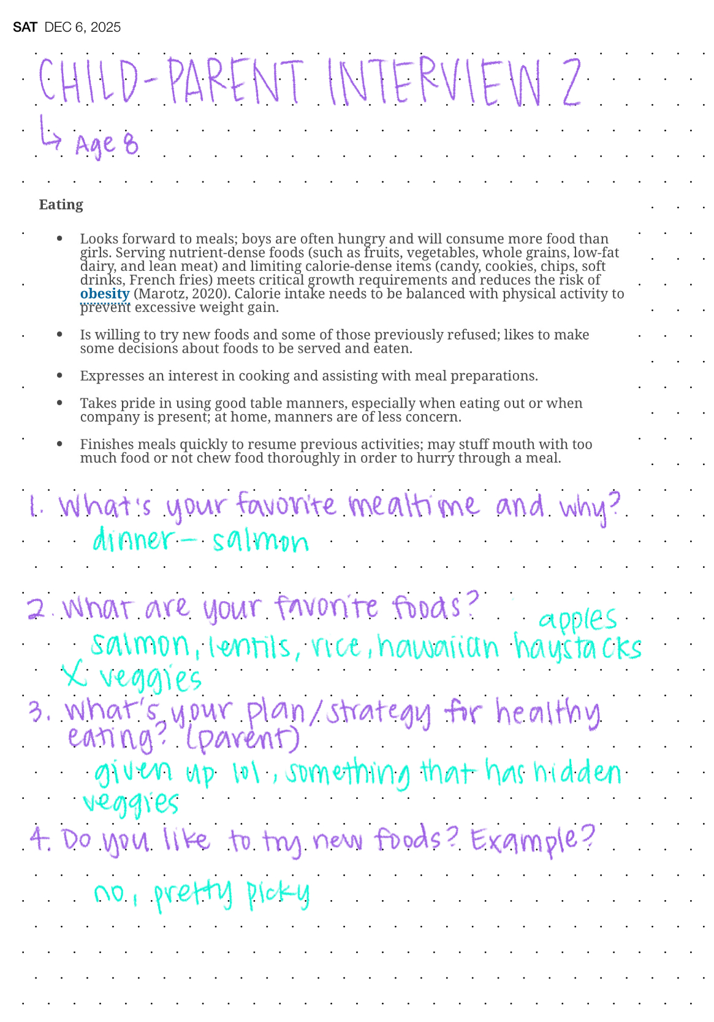
Appendix

